**FRESHCO HYPERMARKET CAPSTONE**

**REPORT**

**Introduction**

This report depicts a comprehensive analysis of the Freshco Hypermarket Database. The analysis is divided into four categories which are: **Order level analysis, Completion Rate analysis, Customer level analysis, and Delivery Analysis**. Sharing the insights and observations of each analysis below.

**Order Level Analysis**

* Identified and analysed the order distribution across delivery slots ranging from morning till late night and at delivery area level to understand the pattern in demand. It has been observed that “**HSR Layout area**” has the highest count of orders especially during Afternoon time slot.
* Identified the areas having highest increase in monthly orders from January to September. It has been observed that areas having highest increase in monthly orders are “**HSR Layout, ITI Layout** and **Harlur**.”
* Calculated delivery charges as a percentage of product amount across delivery slots and months. Overall delivery charges are higher in “**Late Night**” time slot.

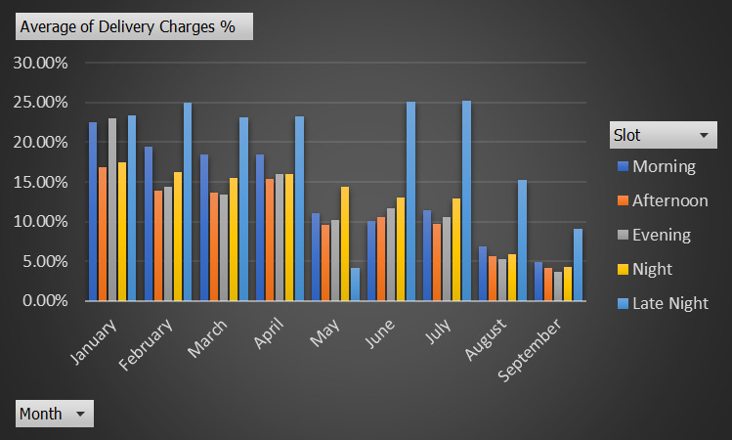

* Calculated discount as a percentage of product amount across delivery slots and months. Maximum discount was offered in the month of “**August**” and during the “**Night**” time slot.

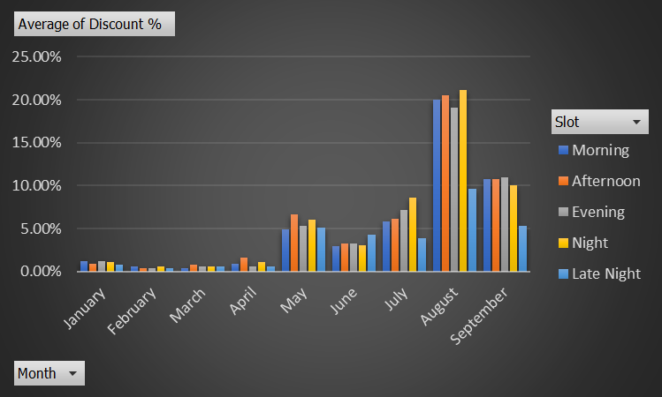

* Calculated discount as a percentage of product amount across drop area and delivery slots. Maximum discount was offered at “**Bilekahalli**” area during “**Night**” time slot.

**Completion Rate Analysis**

* Identified completion rate according to delivery slots and days of the week to check any patterns or trends. It has been observed that the completion rate is relatively higher in “**Afternoon**” time slots.

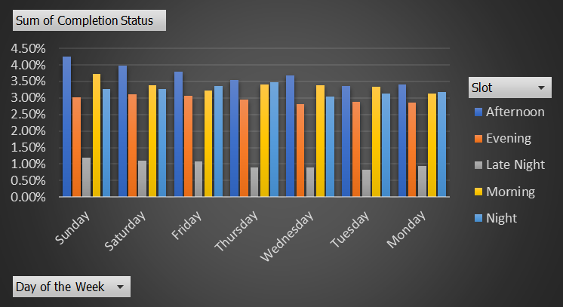

* Calculated completion rates at drop area level to evaluate the efficiency of deliveries in different areas. “**HSR Layout**” delivery area has the highest completion rate.

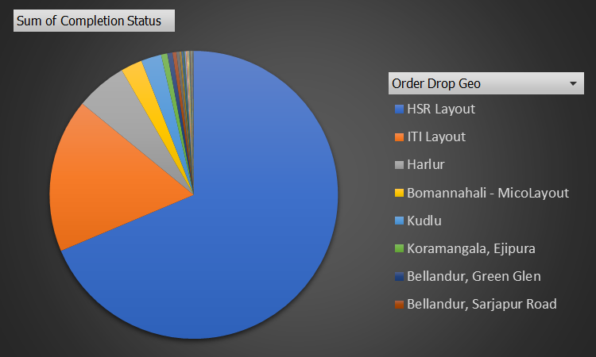

* Calculated completion rate based on number of products ordered to understand the customer preferences. **Count of 1-5 products** ordered has the highest percentage of completion rate.

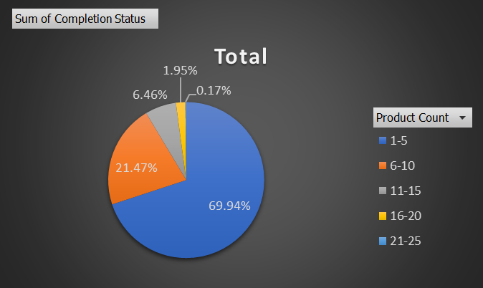

**Customer Level Analysis**

* Identified completion rates based on customer acquisition sources. “**Organic**” acquisition source has the highest percentage of completion rate.

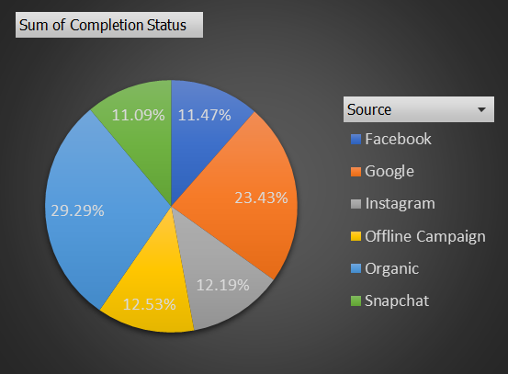

* Calculate LTV (Lifetime Value) for each customer, to understand their profitability. User ID “APQ2413449” has the highest LTV.
* Calculated aggregated LTV across customer acquisition sources and acquisition months. As per the analysis, **highest LTV** is observed for “**Organic**” source and “**January**” month.

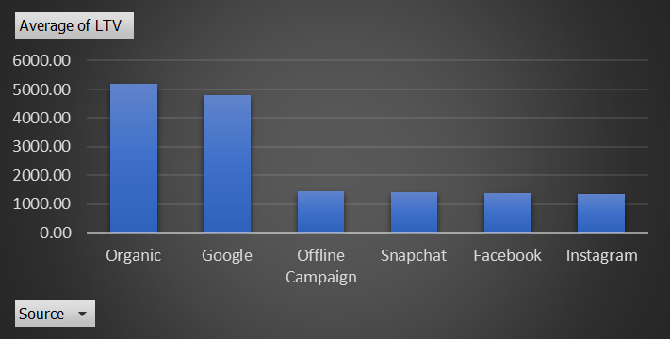

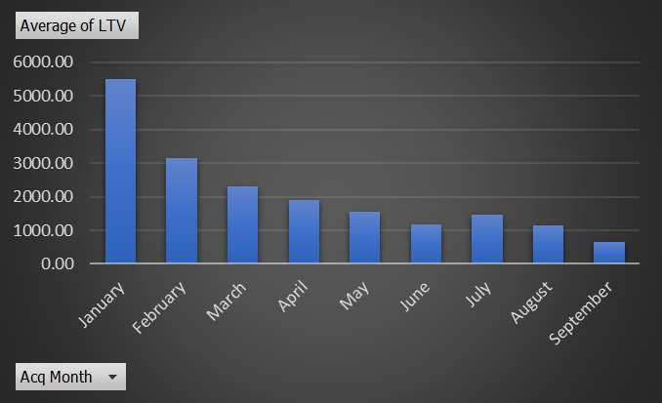

* Calculated the average revenue (product amount after discount) per order across different customer acquisition sources and acquisition months. Highest average revenue per order was generated from “**Snapchat**” acquisition source and in the month of “**January**.”

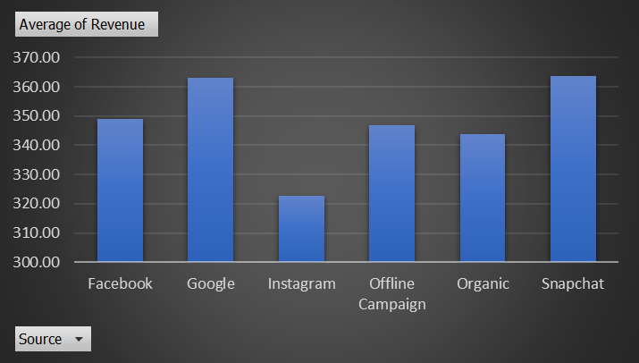

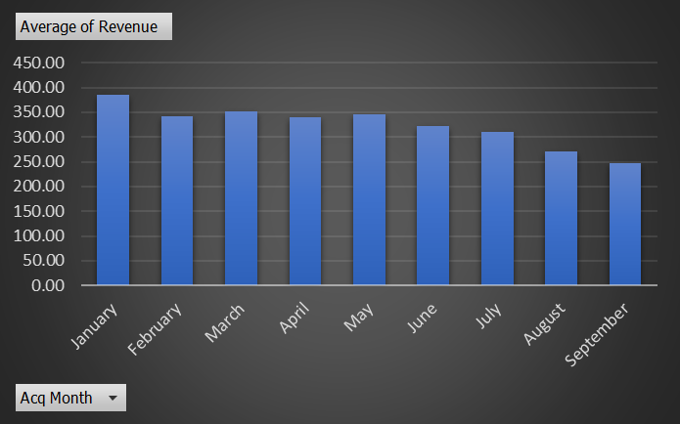

* Identified various patterns in order ratings concerning several factors like delivery slots, number of items placed, delivery charges, and discounts. “**Afternoon**” time slot, having the highest number of order rating.

**Delivery Analysis**

* Calculated the average overall delivery time at month and delivery area levels. This analysis helps to evaluate the efficiency of deliveries in different areas. “**June”** month has the lowest delivery time. HSR Layout area has low delivery time in all the months.
* Calculated the average overall delivery time at month and weekday/weekend levels to assess the delivery performance. “**May**” month has the highest amount of delivery time over both weekdays and weekends.

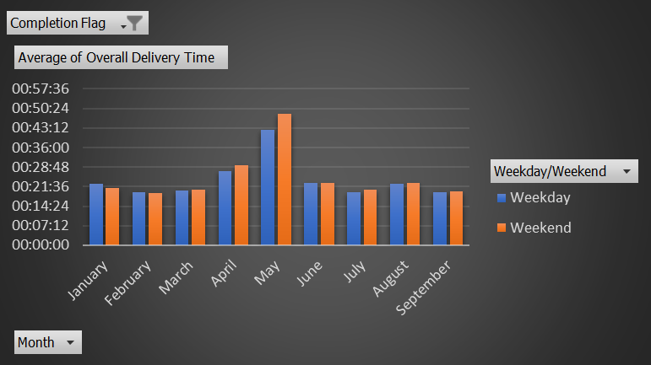

* Calculated the average overall delivery time across delivery slots. “**Late Night**” time slot has low delivery time.

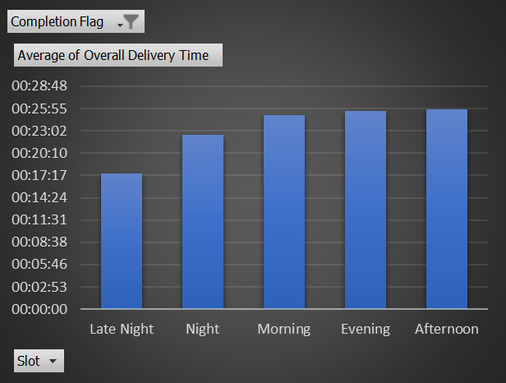

* Examined different patterns in delivery charges with respect to slots and delivery areas. Delivery Charges at “**Late Night”** is comparatively higher in Brookefield, CV Raman Nagar and Frazer Town areas.
* Identified patterns in delivery time and delivery area. Overall delivery time is lowest in “**HSR Layout**” area.

**Conclusion**

The detailed analysis of the Freshco Hypermarket Database has provided some valuable insights on various aspects like order distribution, completion rates, customer behaviour, and delivery efficiency. These insights are useful in making data-driven decisions and implementing strategies for improving overall business performance. Therefore, it is recommended to implement the strategies basis the patterns observed in the data to enhance customer satisfaction, delivery efficiency and order completion rates.

Chavi Madan